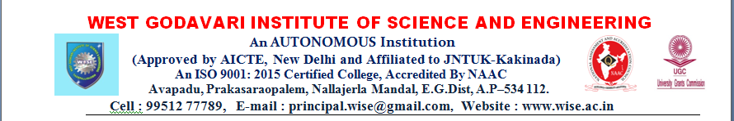

IQAC Committee

S.No. | Member Name | Designation | Category/Position
1 | Dr.M.Aravind Kumar | Principal | Chairman
2 | Sri.L.Sankar | HOD- ECE | IQAC Co-Ordinator
3 | Dr.A.S.Prasad | HOD-MBA | Member
4 | Dr.P.Amaravathi | HOD-CSE | Member
5 | Smt.N.L.Tejaswini | HOD-CSE-DS | Member
6 | Sri.K.Muralidhar | HOD-MECH | Member
7 | Sri.K.Jayarama Krishna | HOD-H&S | Member
8 | Sri.T.V.V.Anjaneyulu | Admin Officer | Member
9 | Sri.P.Ganapathi Raju | Industrialist | Member
10 | Sri.N.Kondayya | Alumni | Member

